

The Roughneck 2.0 #20125-1

Thank you for purchasing The Roughneck 2.0 electronic caller. To see more Lucky Duck™ products please visit your local Sporting Goods dealer or online at www.luckyduck.com.

Directions for use: Unpack the box and make sure all parts are present.
1 – Roughneck 2.0 Electronic Call
1 – LD2X Remote Control
1 – SD Card (installed)
- Roughneck 2.0 Electric Call Cover (installed)
- LD2X Remote Control Cover (installed)
- Rechargable Battery Pack
- 10AA Spare Battery Holder
- E Caller Bag

Battery Installation: The call uses a 12 volt 3,700 mAH lithium ion battery and charger (included). The battery cartridge is located on the back of the call. Simply remove the battery cover, insert the battery cartridge. The remote control uses 3AA batteries (not included). Remove the battery cover on the back of the remote control and install the batteries.

Electronic Call Operation: Flip the power switch on the electronic call forward to the “on” position. A red LED light on the back of the call will illuminate when the power is on. Hold down the power button on the remote control. The remote will turn on. The remote screen will display “Finding Caller” while it searches for the caller. Once connected the main caller the home screen will be displayed. On the bottom of the home screen it should say SD Link OK confirming the remote and caller are connected and in sync. DO NOT PRESS ANY BUTTONS WHEN REMOTE IS SEARCHING FOR THE CALLER.

Reboot: For 2018 and newer callers, a reboot function is available to resync the remote and call if the connection between the two is lost while hunting or the sound files are not displayed correctly. Simply press and hold the “auxilliary” button to reboot the remote and resync. The remote screen should turn blue and go through the “Updating” process as described in the Electronic Call Operation section above. DO NOT PRESS ANY BUTTONS WHEN REMOTE IS SEARCHING FOR THE CALLER.

Remote Control Operation:
Sound Selection – Use the up/down arrows to highlight the folder you want to select. Press the play/pause button to select the folder. Use the up/down arrows to highlight the sound you want to play. Press the play/pause button to play the sound. Holding the up/down arrows down for 1 second will cycle through the folders/sounds faster.

Volume Selection – Use the vol- and vol+ buttons to lower or increase the volume level. The volume level ranges from 1 to 32. Holding the vol- or vol+ buttons for 1 second will raise or lower the volume level quickly.

Back Button – The back “B” button is used to go from the sound list back to the folder list.

Recall Button – The recall button will play the previous sound.

Display Screen – The remote display screen includes information on the top 2 lines as well as the bottom line.
Top Line (Left to Right)
- Stand timer which starts from zero when the remote is turned on
- Volume level from 1 – 32
- Remote control battery level indicator
Second Line (Left to Right): Each icon will be highlighted when in use
- AUX indicates if the auxiliary function is turned on
- SD indicates if the SD card is installed and synced to the remote
- Signal indicates the strength of the signal between the remote and caller
- Speaker indicates if a sound is being played
Bottom Line: Shows remote channels

Remote Screen Brightness: The LD2X remote features 3 different screen modes to adjust brightness depending on the outside light level. Simply press and hold one of the three indicator buttons to change the mode. The top “D” button is for “Day” mode, the middle “DD” button is for “Dawn/Dusk” mode and the bottom “N” button is for “Night” mode.

Remote Control Distance: The LD2X remote utilizes industry leading remote technology which does not require a line of site between the remote and the caller up to at least 100 yards. Depending on conditions, remote distance may be significantly greater than 300 yards.

E Caller Bag: The Roughneck 2.0 comes with a E Caller Bag that is great for storage and transportation.

Favorite Buttons: F1-F3 are designed to store your four favorite sounds for quick access when hunting. Press the F1 through F3 button once to play the programmed sound at the predefined volume level.

Program F1 through 3 – Simply highlight the sound you want to program as a favorite and adjust the volume to your preferred level. Hold down the corresponding F1 through F3 button. The highlighted sound will flash on the display screen confirming the programming is complete. IF THE F1 BUTTON WILL NOT PROGRAM, TRY PROGRAMMING F2, OR F3 FIRST AND THEN PROGRAM F1.

Gain Control: Unique to the Roughneck 2.0 is a four stage gain control function. The gain on this caller has four settings (1-4). One being the lowest and four being the highest (loudest). Whenever the caller is turned on it is set to gain level of “3”. By adjusting the gain, you are able to control the power running through the amp. You will notice a difference in the volume of the call between level 1 and level 4. Certain sound frequencies sound much better at a high gain where others sound better at a low gain. Knowing you may be adding your own sounds to this caller, adjusting the gain may be useful depending on the sound being played since each sound recording is different. Adjusting the gain may also be useful depending on the hunting situation. For example, turning the gain to level 4 in strong wind conditions may be beneficial even if the sound quality is reduced (i.e. distortion).

Adjust Gain – Press the “G” key to cycle through the gain levels. The gain level will display on the display screen.

Auxiliary Function: The Revolt is designed with an auxiliary function which allows a separate decoy to be controlled remotely by connecting a compatible decoy (not included) to the back of the caller using a 3.5mm cord (not included). Simply plug one end of the 3.5mm cord into a compatible decoy and the other end into the auxiliary port on the back of the caller. Turn on the compatible decoy and the caller/remote. The auxiliary button “AUX” on the remote will now turn the compatible decoy on and off. The AUX icon on the top of the display screen will be highlighted when the auxiliary function is used.

Sound Management: The Roughneck 2.0 comes preloaded with 200 live animal sounds organized in 17 folders for quick access. These sounds have been professionally recorded by The Verminator, Rick Paillet. We firmly believe this is the best sound library on the market. The 200 preloaded sounds have the extension .LD. They will only play on Lucky Duck electronic calls. Any reproduction of the these sounds is strictly prohibited. Check out www.luckyduck.com for additional sounds to purchase.

Add/Remove Sounds: The Roughneck 2.0 features an industry leading wireless 2 way communication system between the remote and caller. This makes syning the caller to the remote extremely easy and quick.
- Press the SD sound card in to eject the sound card and remove the SD sound card from the back of the caller
- Add or remove the folders and sounds on the SD sound card using your computer. View the files just like you would view files on a standard camera sd card.
- Reinstall the SD sound card into the caller (top side or label side of the SD card should face the left side of the caller when reinstalling)
- Turn on the caller and remote and let them sync with each. Most syncs will take 5-30 seconds. As stated in the “Electronic Call Operation” section, the remote screen will display “Finding Caller” “Waiting” while it searches for the caller. Once connected the remove screen will display “Updating” and “Communication OK”. The main home screen for the caller screen will then display.

It is important to note the maximum number of sounds are 2,000 and the maximum number of folders are 32. There can only be one level of folders. You cannot create a folder within a folder. The file names can be as long as you would like but the display screen will only show the first 20 characters. The caller will play .LD, and .mp3 files.

Charging Port: The Roughneck 2.0 is equipped with a charging port which is only to be used with the Lucky Duck rechargable battery packs and chargers. The charging system is not to be used with any other types of battery packs or chargers. Use of any other battery packs or chargers voids all warranties.

To Recharge the 12 Volt Lithium Ion Battery (two methods)
Caller Port:
- Simply plug your charger into the charging port located on the back of the call. It should be the middle port under the black cover.
- Plug the charger into an 110V wall outlet. The LED light on the charger will turn red when charging and green when fully charged. It should take 4 hours to recharge a battery.
Battery Directly:
- Remove the battery cartridge from the back of the caller.
- Plug the charger into the charging port on the bottom of the battery.
Plug the charger into an 110V wall outlet. The LED light on the charger will turn red when charging and green when fully charged. It should take 4 hours to recharge a battery.

Care and Maintenance
- The Roughneck 2.0 is not waterproof. Take caution to keep rain and snow away from the caller and remote. If the caller or remote becomes wet make sure to dry it off/out.
- There is a small drain on batteries even when the power is off. It is recommended to remove the batteries from the remote and remove the battery pack from the caller between hunts to extend battery life.
- The caller has a remote control storage adapter located on the top of the caller handle. Insert the remote clip into the storage adapter. Do not transport the remote in the storage adapter as the remote may come unattached.

Troubleshooting:
- If the caller or remote does not seem to be operating properly or the sync function does not seem to be working after changes have been made to the SD sound card, turn the caller and remote off and remove the batteries from each unit. Reinstall the batteries and turn the remote and caller back on as described in the operations section.
- For 2018 and newer callers, a reboot function is available to resync the remote and call if the connection between the two is lost while hunting or the sound files are not displayed correctly. Simply press and hold the “auxilliary” button to reboot the remote and resync. The remote screen should turn blue and go through the “Updating” process as described in the Electronic Call Operation section above. DO NOT PRESS ANY BUTTONS WHEN REMOTE IS SEARCHING FOR THE CALLER.

Lucky Duck™ warrants this product against all manufacturing defects for a period of 1 year from date of purchase. Proof of purchase is required. Abuse of the product (water damage, dropped, mistreatment etc.) is not covered. Please return and exchange the defective unit to the store where you purchased the product. If the store will not accept the return, please email or call customer service at customerservice@luckyduck.com or 715-338-3183.

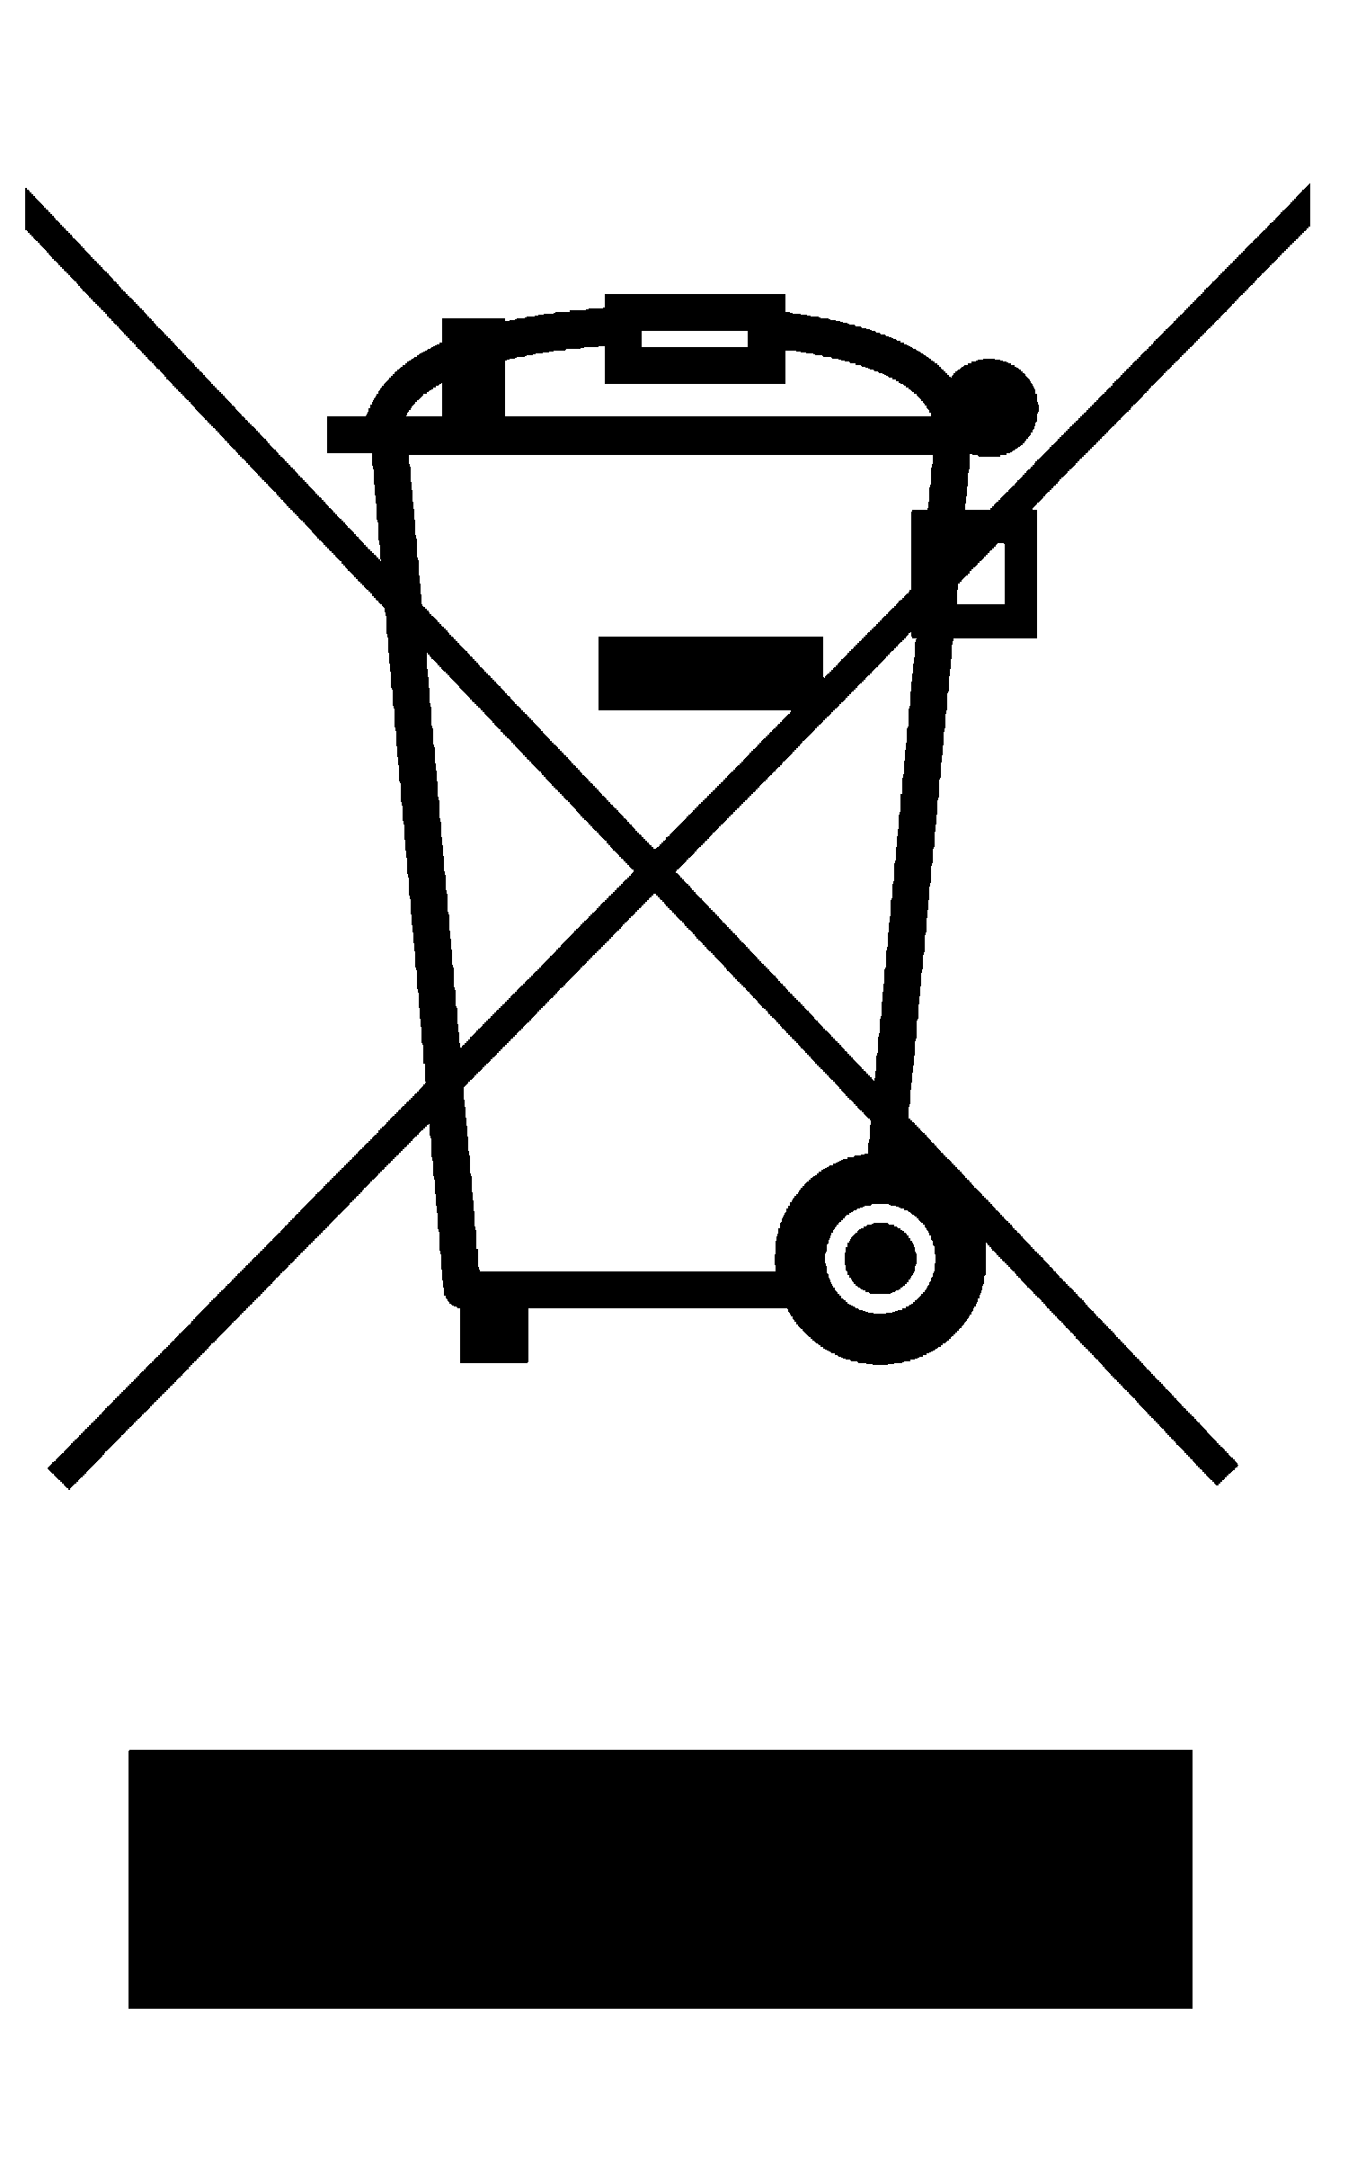

The Roughneck 2.0 Layout
Volume –
Play/Pause
Volume +
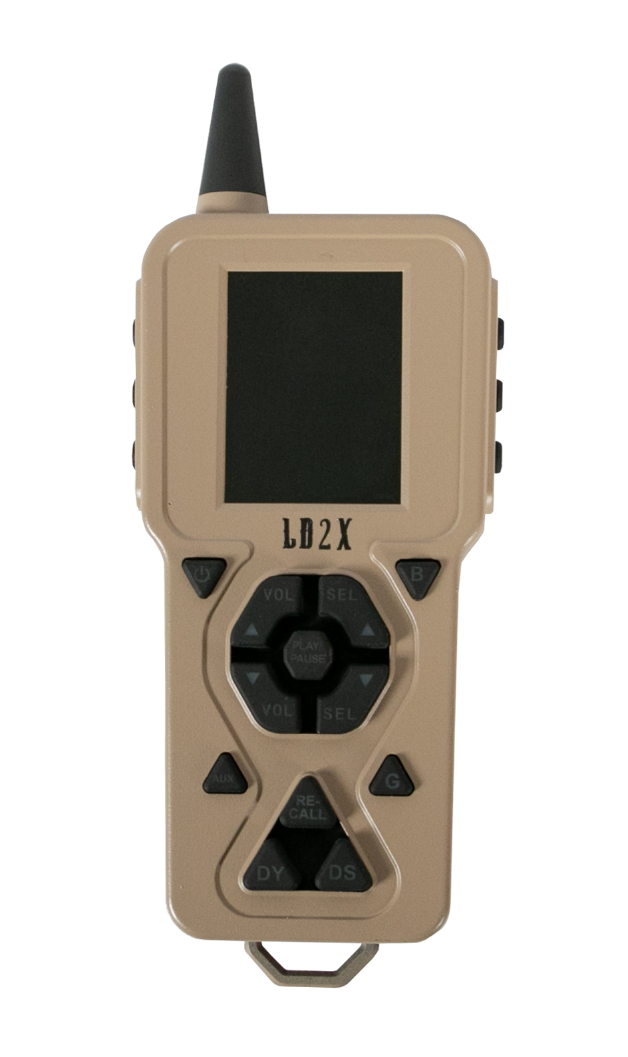
Aux
Re Call
Decoy Spin/Speed
Tripod Base
Back
G – Gain Adjustment
Tweeter Speaker
Favorite Sounds 1-3
Power IndicatorLight
On/Off
Power Horn Speaker
Channel Selector
Antenna
Screen Brightness
LD2X Remote
Decoy

